Week 2 – 20/01/2025 – 24/01/2025
Shell Scripting
Day 1: Introduction to Shell Scripting
Topics Covered:
- What is Shell Scripting?
  - Shell scripting is a way to automate tasks using scripts that can execute commands in the terminal. It is used to perform operations like managing files, configuring the system, and automating repetitive tasks.
- Types of Shells
  - The most common shell is Bash (Bourne Again Shell), but others include Zsh, Fish, and Csh.
- Basic Structure of a Shell Script
  - A script is a file that contains a series of commands.
  - A script starts with a shebang (#!/bin/bash), which specifies the interpreter.
Example:
#!/bin/bash
echo "Hello, Shell Scripting!"
- Running a Shell Script
  - To run a script, you first need to make it executable:
  - chmod +x script.sh
  - ./script.sh

Day 2: Creating Basic Scripts
Topics Covered:
- Creating Your First Script
  - A simple shell script to print a message.
  - Example:
  - #!/bin/bash
  - echo "This is my first shell script!"
- Making the Script Executable
  - Use the chmod command to make your script executable.
  - Example:
  - chmod +x first_script.sh
  - ./first_script.sh
- Basic Output with echo
  - The echo command is used to print text to the terminal.
  - Example:
  - echo "Welcome to Shell Scripting!"

Day 3: Initializing Variables and Arrays
Topics Covered:
- Initializing Variables
  - A variable is used to store a value that can be used throughout the script.
  - Example:
  - #!/bin/bash
  - my_variable="Hello, World!"
  - echo $my_variable
- Arrays
  - Arrays are used to store multiple values in a single variable.
  - Example:
  - #!/bin/bash
  - my_array=("apple" "banana" "cherry")
  - echo ${my_array[1]} # Output: banana
- Accessing Array Elements
  - Array elements can be accessed using indices, starting from 0.
  - Example:
  - echo ${my_array[0]} # Output: apple

Day 4: Adding Comments and Performing Operations
Topics Covered:
- Adding Single-Line Comments
  - Comments are used to explain the script and make it more readable. They start with a #.
  - Example:
  - # This is a single-line comment
  - echo "Hello, World!"
- Adding Multi-Line Comments
  - In shell scripts, multi-line comments can be done by starting each line with a # or using : '.
  - Example:
  - : '
  - This is a multi-line comment
  - that explains the script.
  - '
- String Operations
  - You can manipulate strings by concatenating them or performing operations like substring extraction.
  - Example:
  - str="Hello"
  - echo "$str World!" # Output: Hello World!
- Arithmetic Operations
  - Shell scripting supports basic arithmetic operations like addition, subtraction, multiplication, and division.
  - Example:
  - a=5
  - b=3
  - sum=$((a + b))
  - echo $sum # Output: 8

Day 5: Understanding Cron Jobs and Special Symbols
Topics Covered:
- Understanding Cron Jobs
  - A cron job is a time-based job scheduler in Unix-like operating systems. It allows you to run scripts at specified intervals.
  - Example: Setting up a cron job to run a script every day at 5 AM.
  - 0 5 * * * /path/to/script.sh
- Editing Crontab
  - Use the crontab -e command to open the cron job editor.
  - Example to run a script every day at 5 AM:
  - 0 5 * * * /home/user/scripts/backup.sh
- Special Symbols in Shell Scripting
  - $?: Exit status of the last executed command.
  - $0: The name of the script.
  - $1, $2, ...: Positional parameters (command-line arguments).
  - Example:
  - #!/bin/bash
  - echo "The script name is: $0"
  - echo "The first argument is: $1"

Day 5: Connecting Multiple Servers Using Passwordless SSH Communication
Objective:
The goal for today’s assignment is to set up passwordless SSH communication between multiple servers (Server A to Server B, Server A to Server C, etc.) using file server.txt . This will allow you to automate tasks across several servers without needing to enter a password each time you SSH into a machine.
Topics Covered:
- Generating SSH Keys on Server A (Source Server)
- Copying the SSH Key to Target Servers (Server B, Server C, etc.)
- Testing Passwordless SSH Access
- Automating Tasks Across Multiple Servers

Server.txt file created
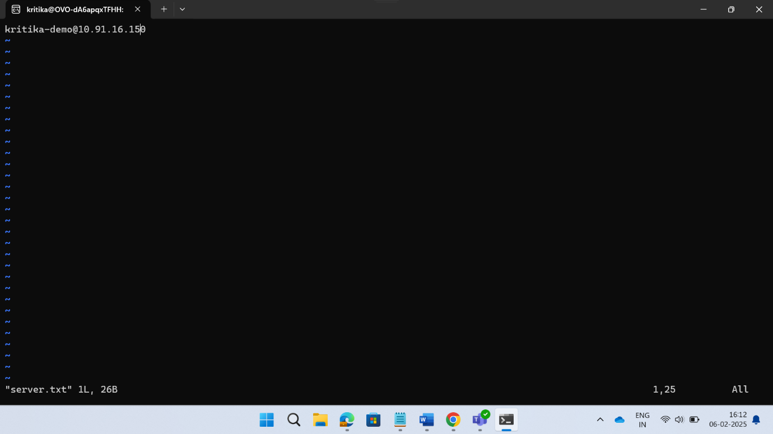

Script for passwordless connections between multiple servers
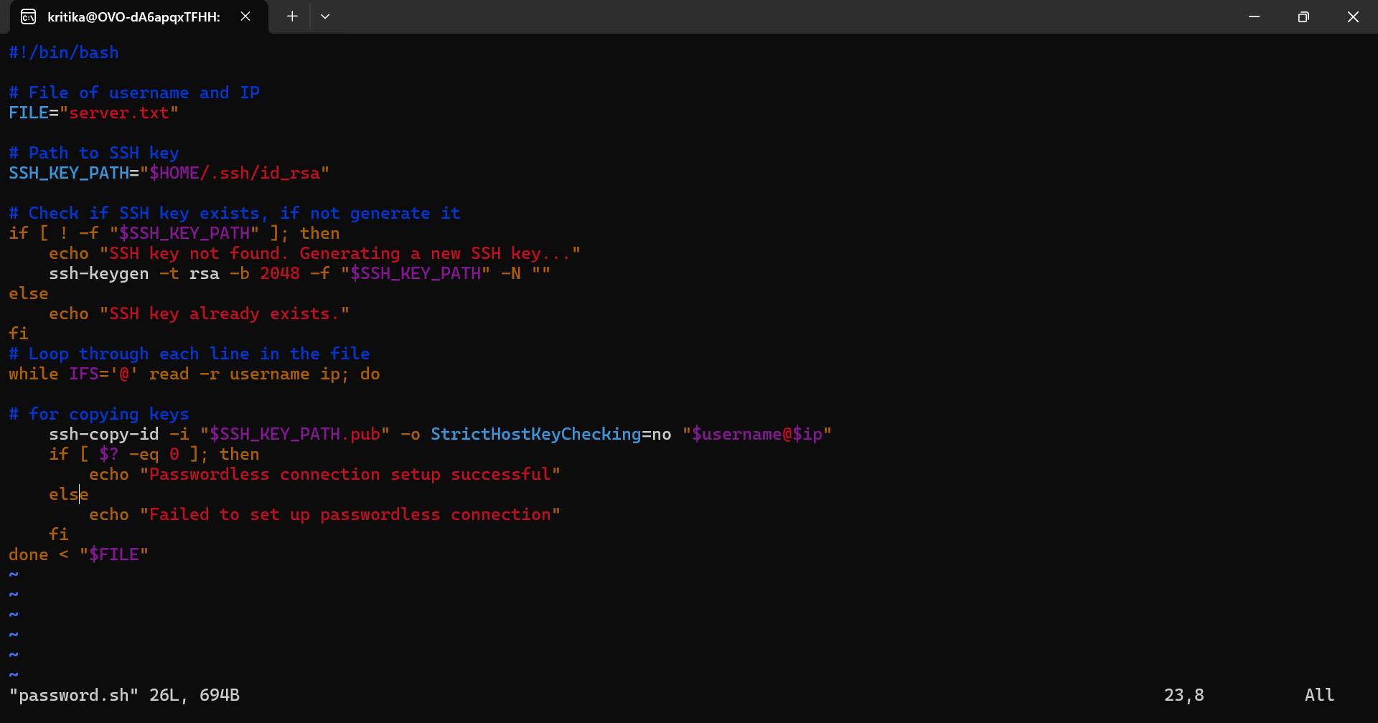

Running script 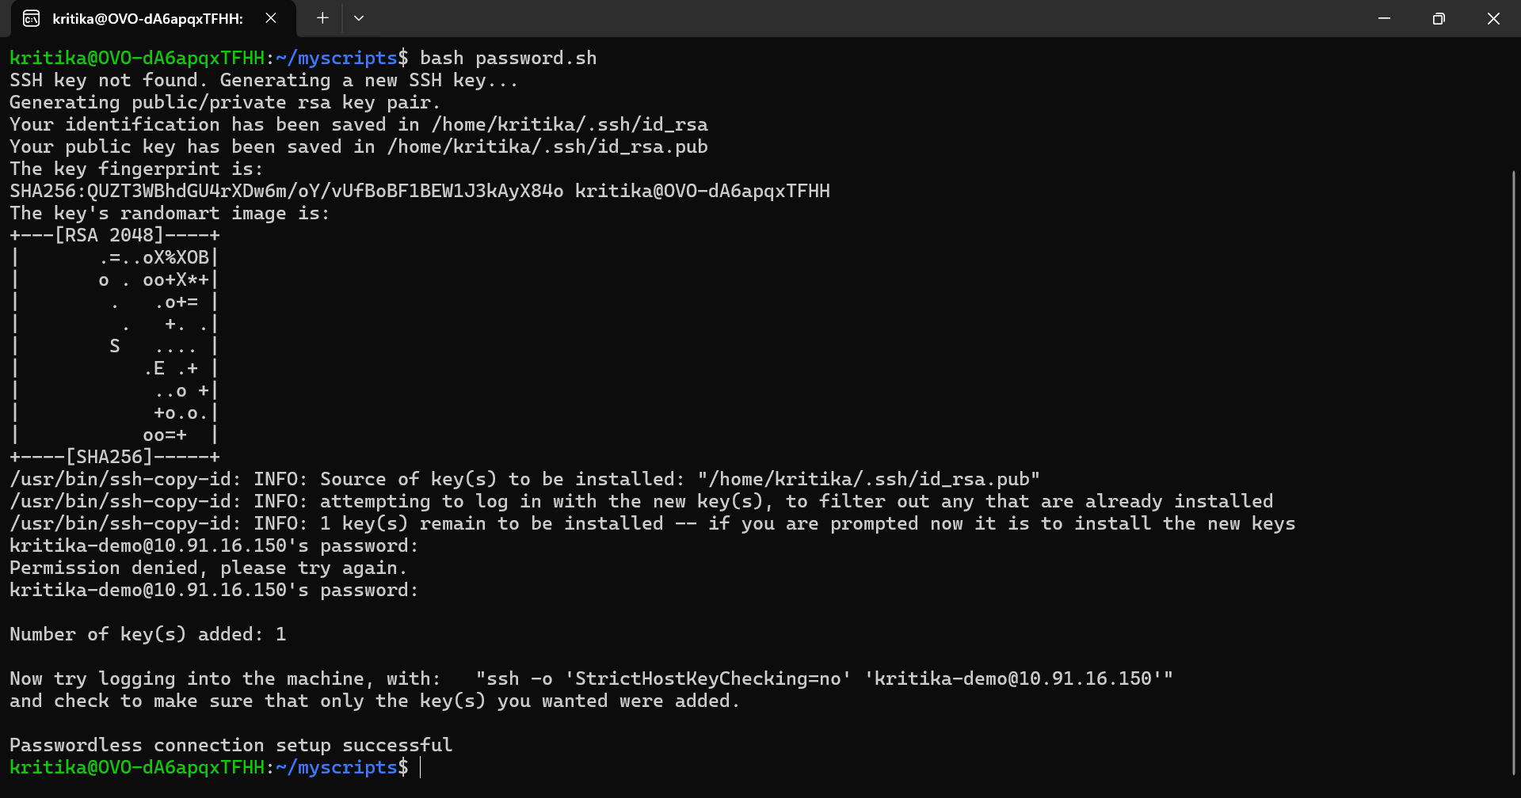

Login to different server after successful running of script
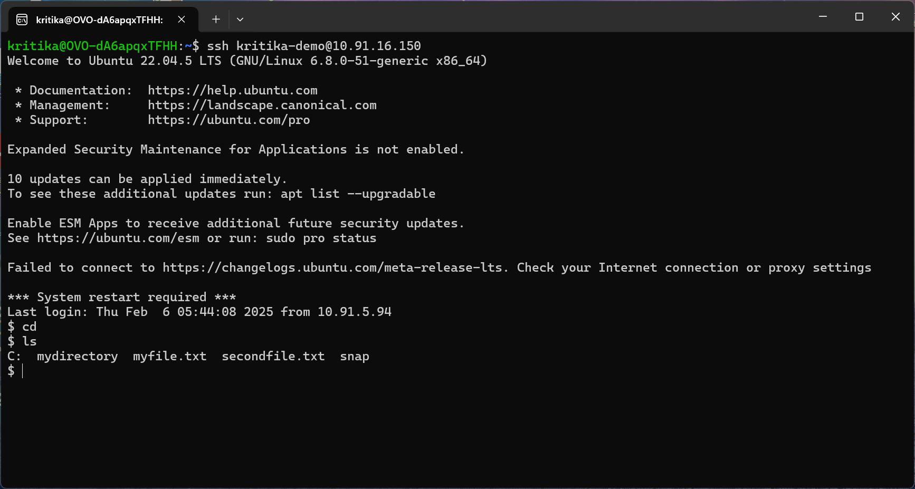

Summary of Week 2:
- Introduction to Shell Scripting: Learned what shell scripting is and how to create and run a basic script.
- Creating Scripts: Wrote basic scripts and made them executable.
- Variables and Arrays: Worked with variables and arrays to store and manipulate data in scripts.
- Comments and Operations: Used comments for clarity and performed basic string and arithmetic operations in scripts.
- Cron Jobs: Set up cron jobs to schedule tasks and explored special symbols used in shell scripting.
- Assignment: Successfully generated SSH keys and set up passwordless communication multiple servers.

